**WORKING WITH IAP**

Account owner : [thecareerbeer@gmail.com](mailto:thecareerbeer@gmail.com)

I am giving permission to parulawsac@gmail.com

* CREATE A PRIVATE VIRTUAL MACHINE

Go vm

Click on networking

And select none in ipv4

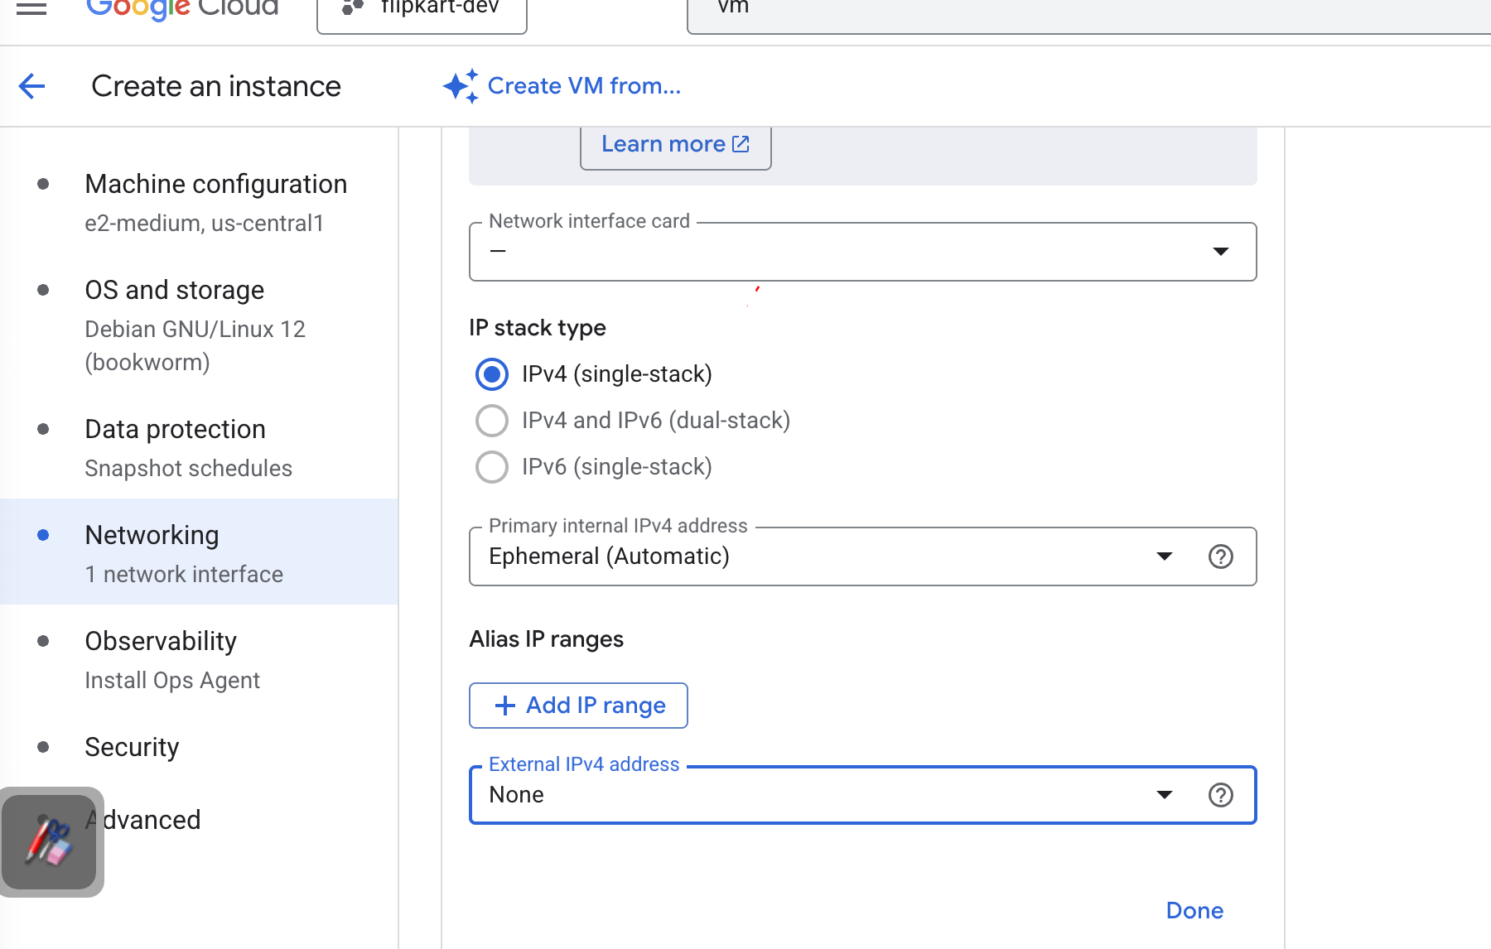



Create the machine

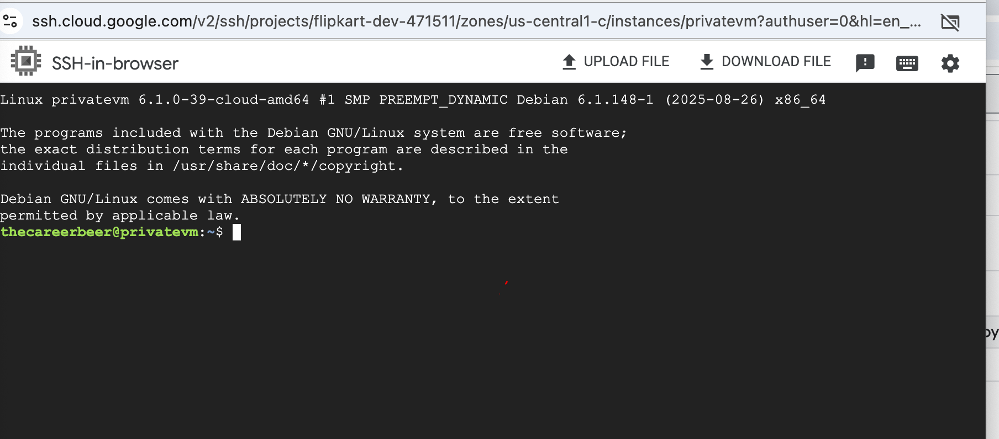

## NOW WE WILL GO TO IAM

IAM

GRAND ACCESS

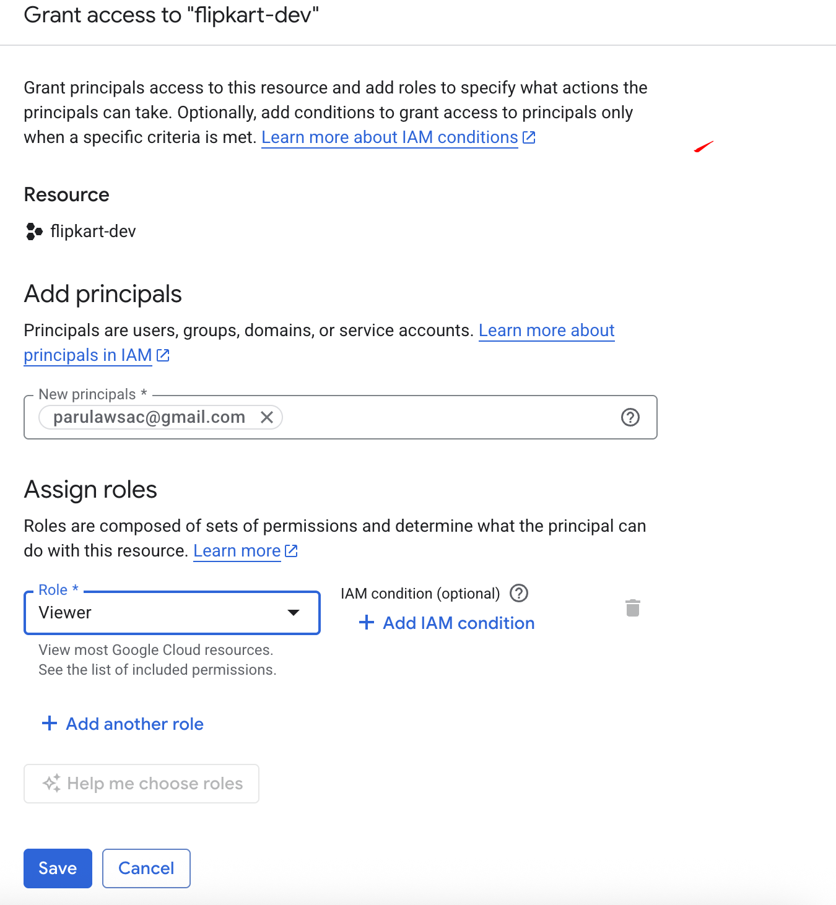



Save

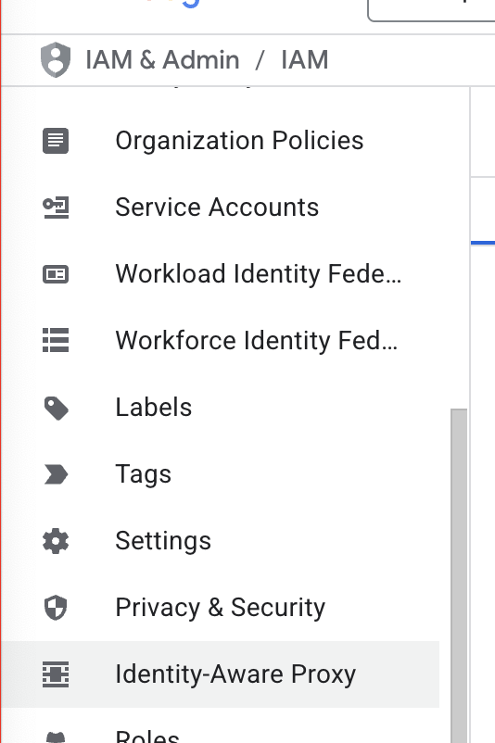



If api is not enable …enable the api

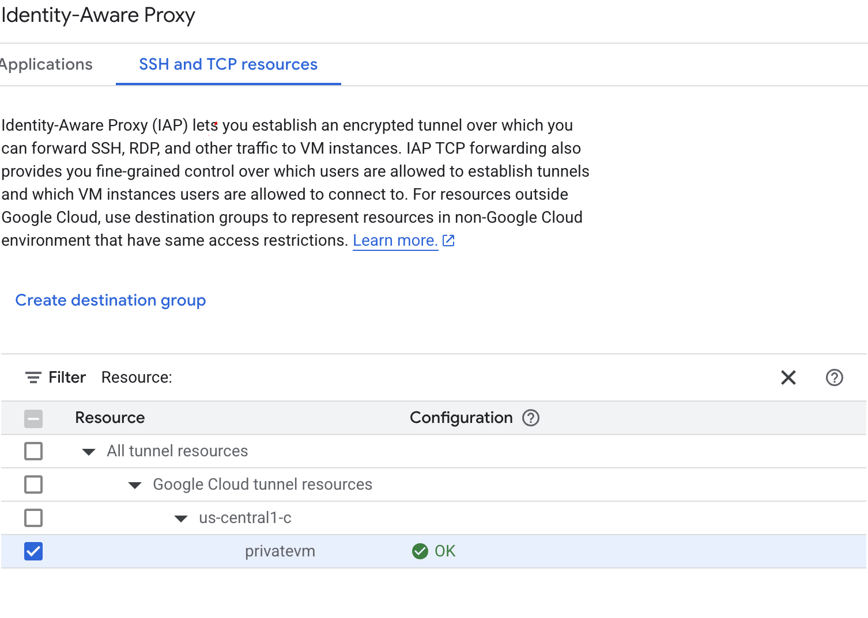

Add principal

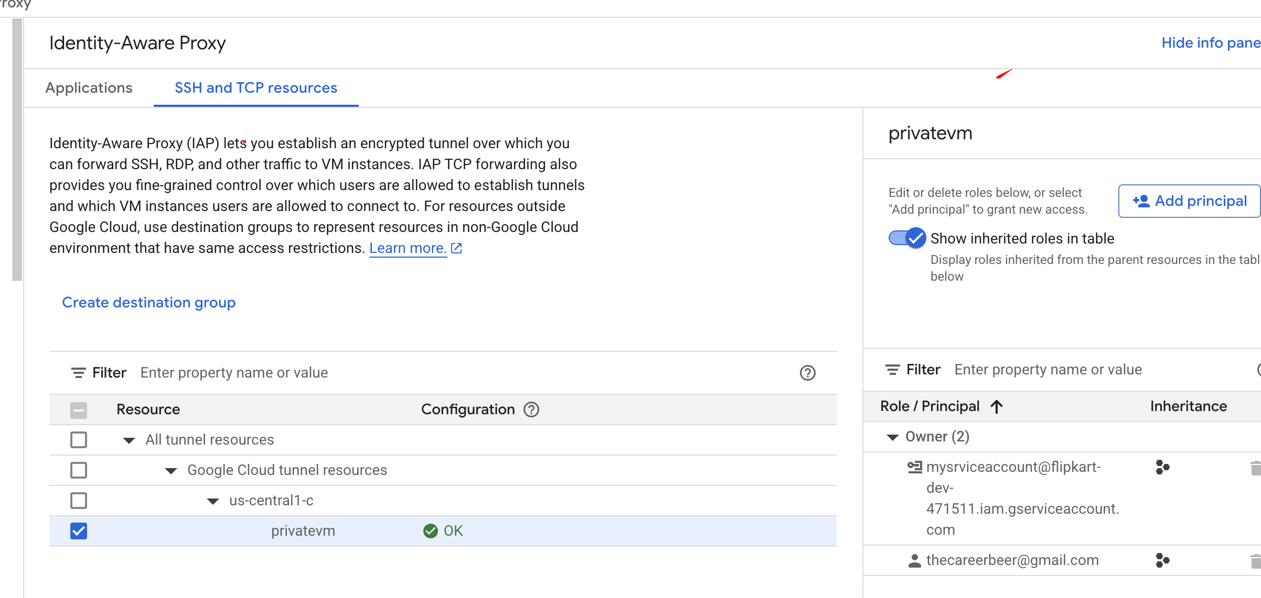

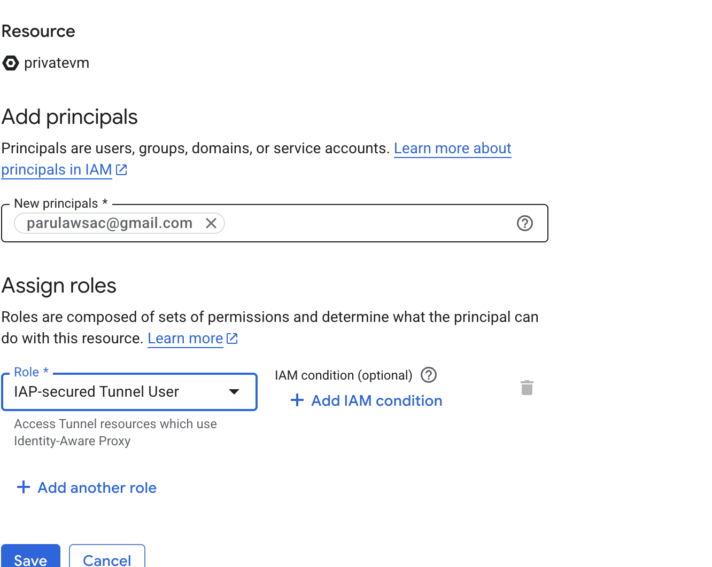

Open cloudshell

In the cloud shell:

gcloud init

Give some configuration name

Select the account

Seleetc the project

In default region select no

### gcloud auth login

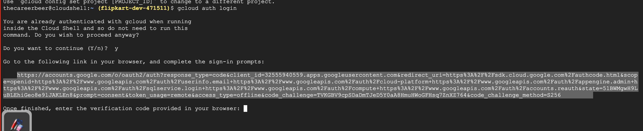

Open this link (share the link with the another account to which you need to authenticate with)

In my case we want [parulawsac@gmail.com](mailto:parulawsac@gmail.com) should be able to authorize the connection

Owner of the account is [thecareerbeer@gmail.com](mailto:thecareerbeer@gmail.com)

After you put verification code you might end up getting some error  
  
ERROR: THERE IS PROBLEM WITH WEB AUTHENTICATOR

ERROR: (gcloud.auth.login) invalid grand Invalid code verifier

SOLVE THE ISSUE:

GO TO IAM

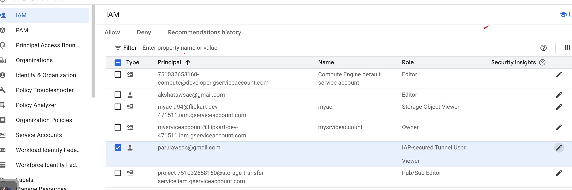

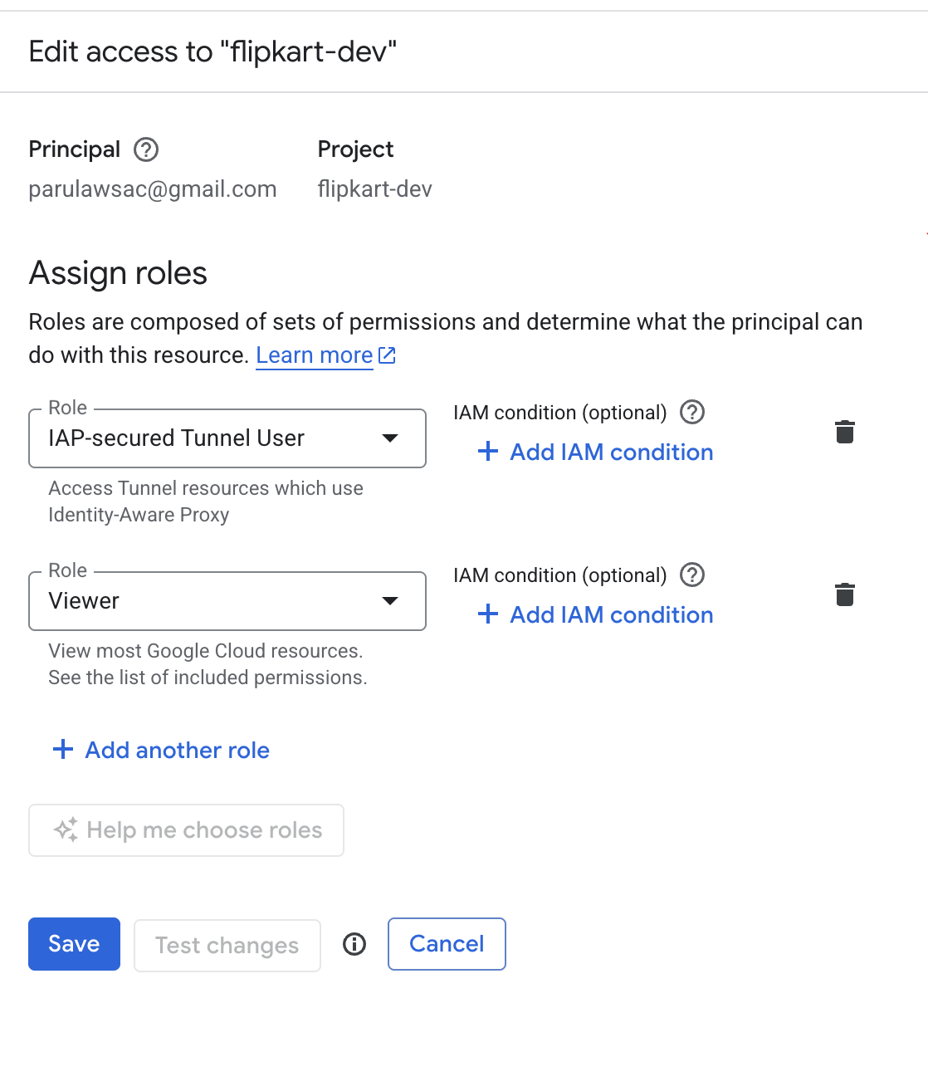



Again go to cloud shell

And run

#gcloud auth login

# here you will get a link open and authenticate with parul account

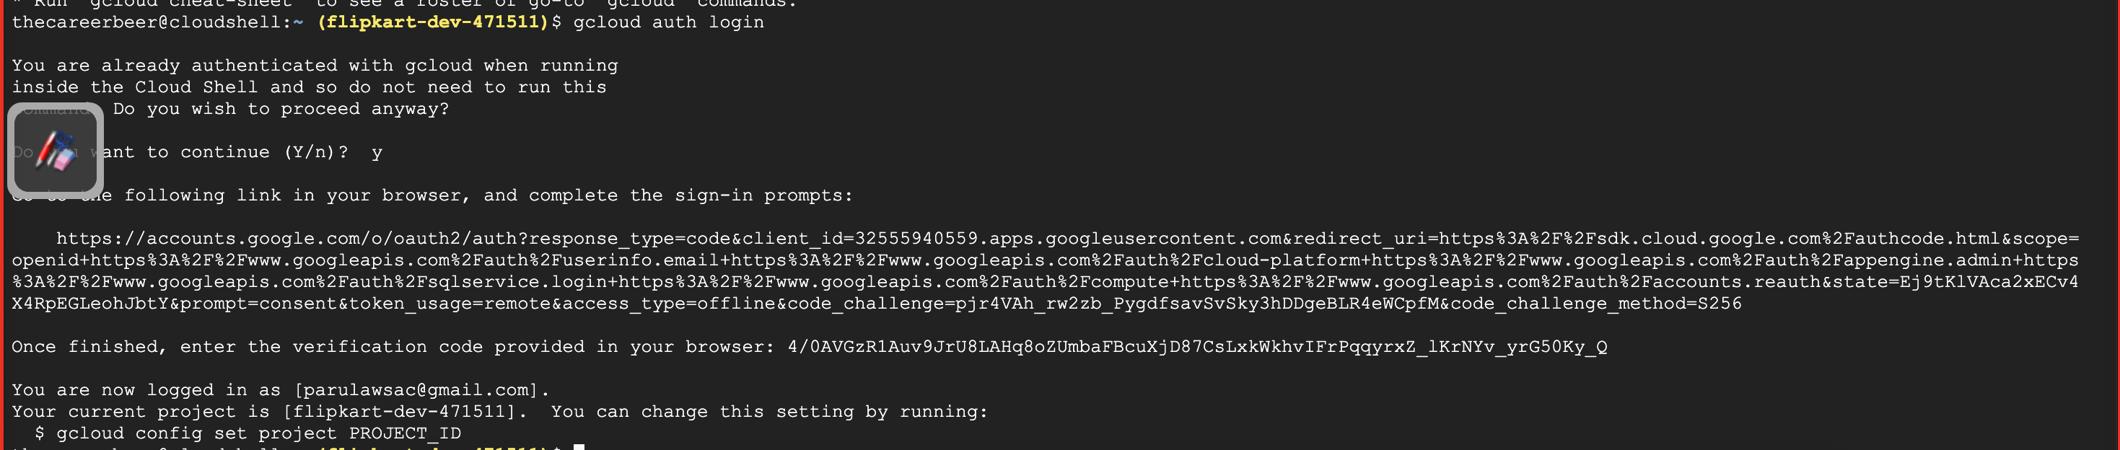

###GO TO IAM -> CLICK ON ROLES -> CREATE ROLES

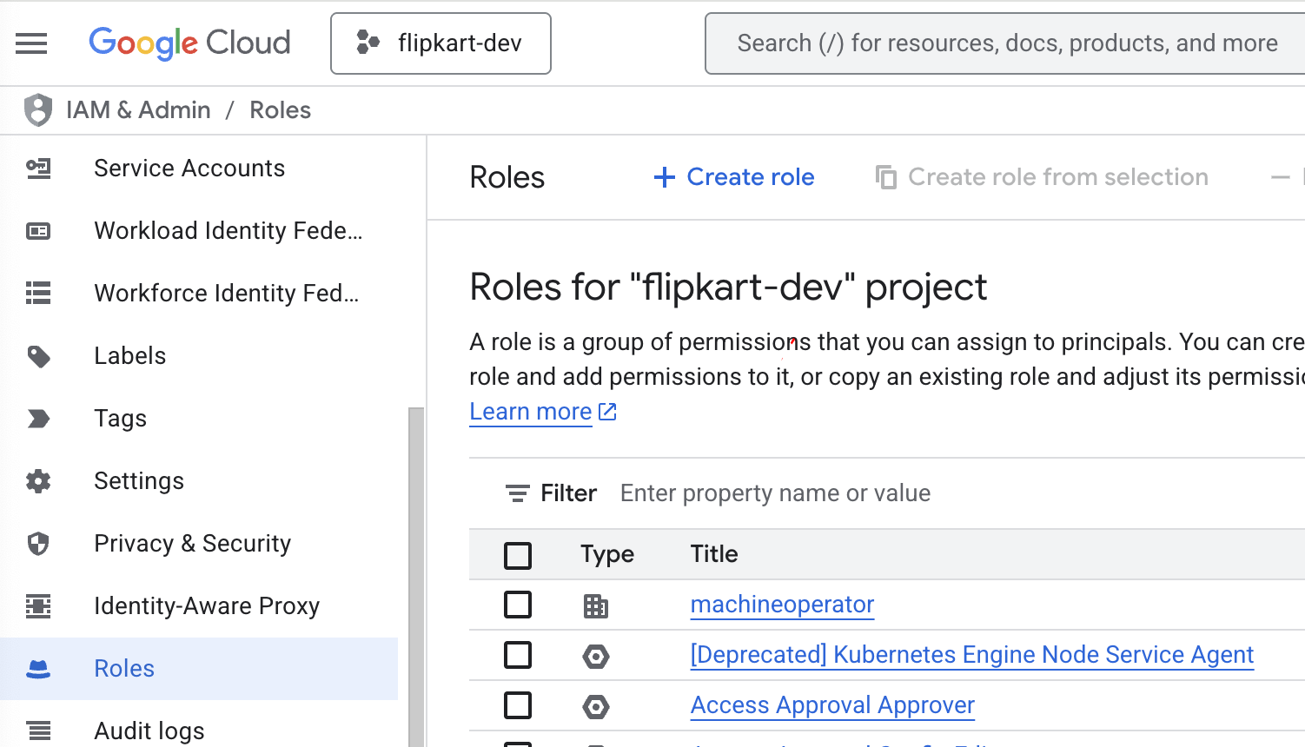



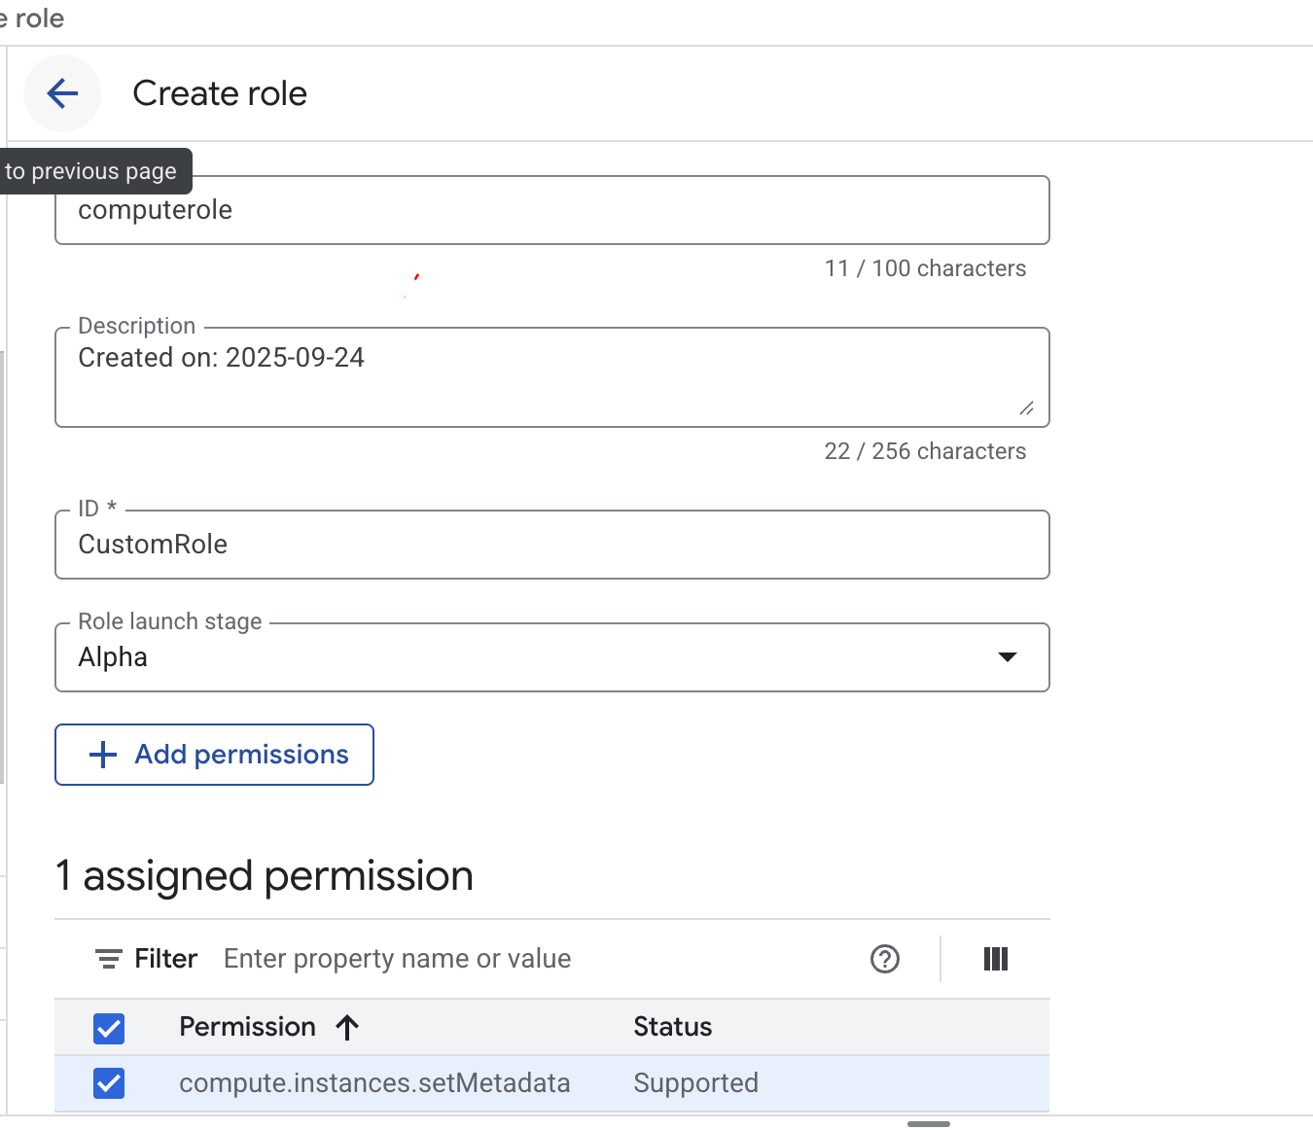

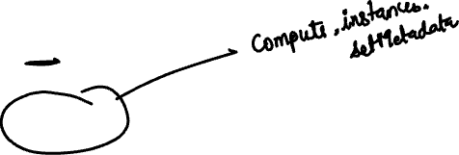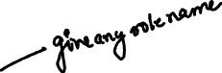

Create

## now we will attach the role to the iam user – parul

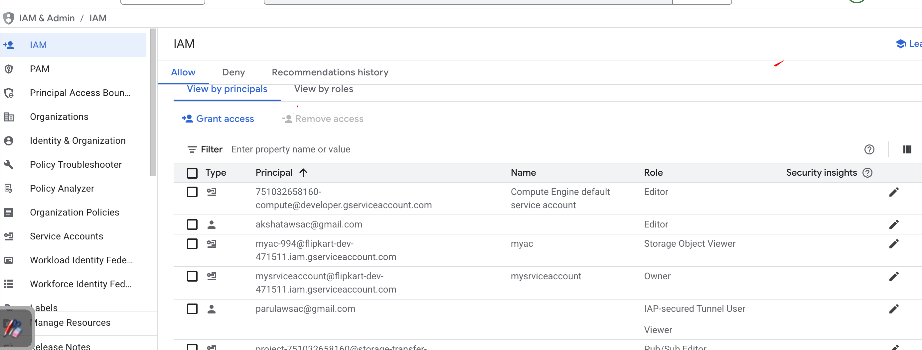



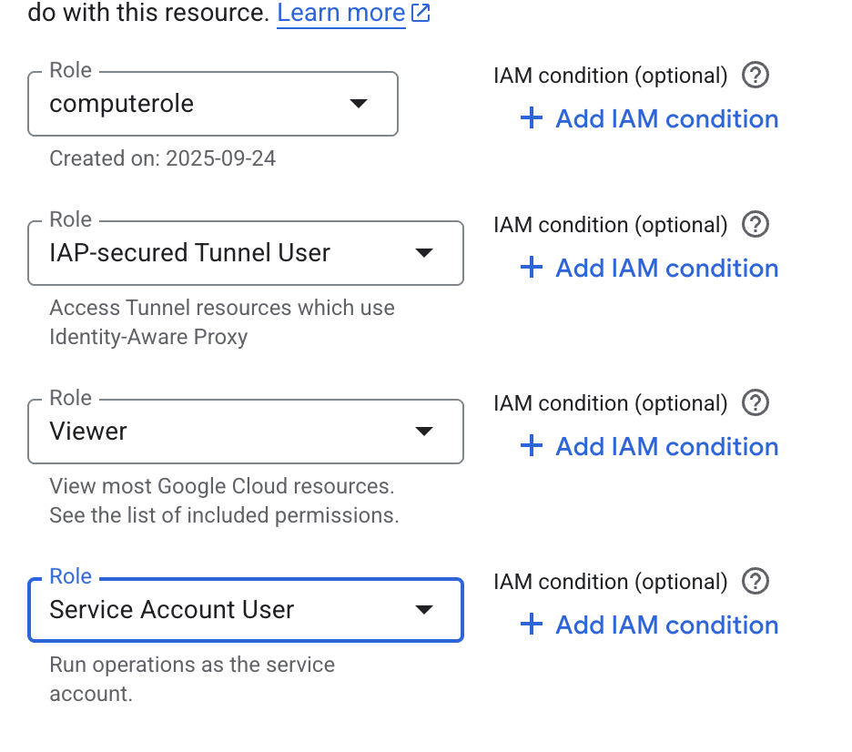

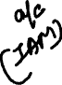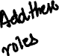

Save

JUST to CHECK first:

In the cloud shell :

# gcloud auth list

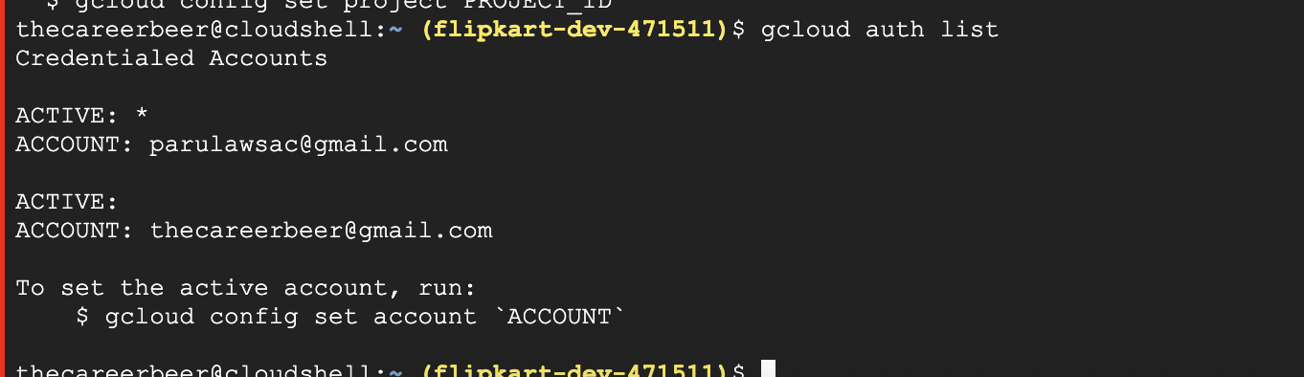



# now we will do the ssh to see if we are able to login

But how to find the ssh command?

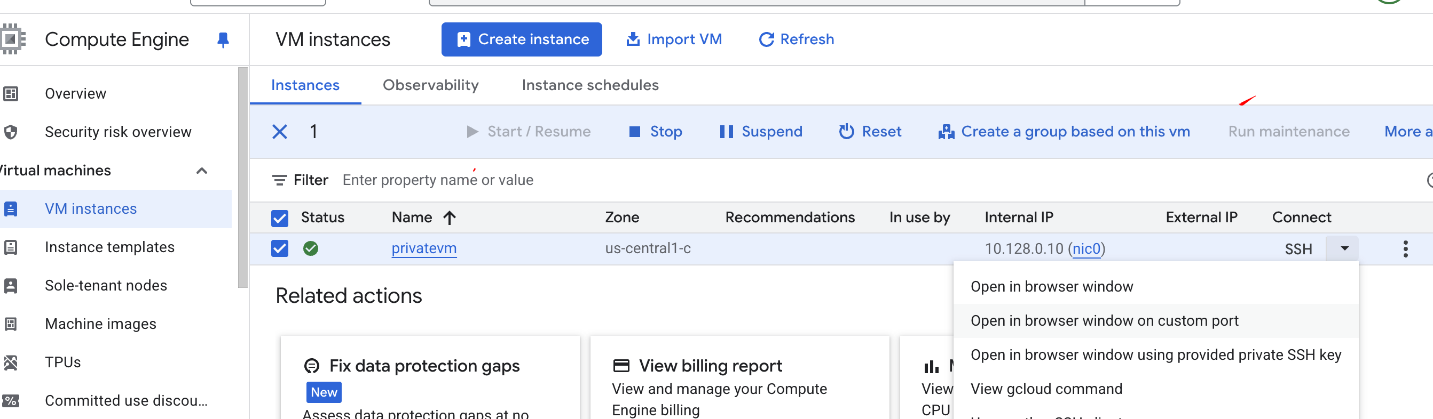



Copy and paste in the cloud shell



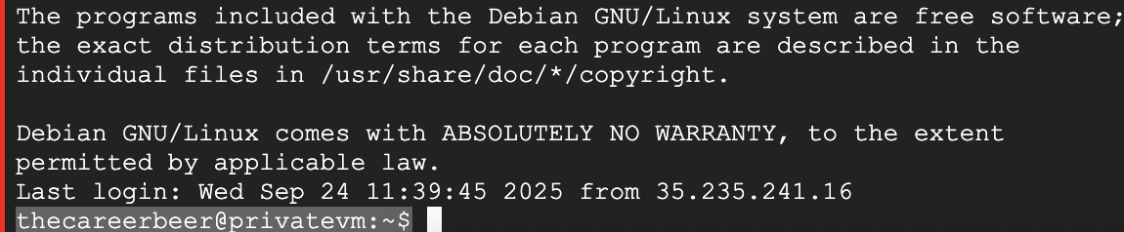

You will be able to login via the parul account